**a = 20, b = 15, c = 10**  
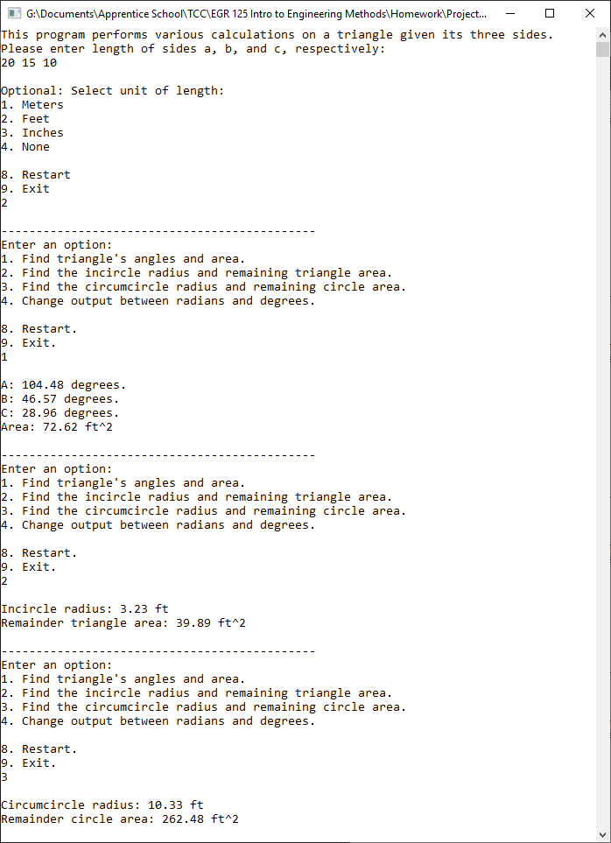

**a = 20. B = 15, c = 25**  
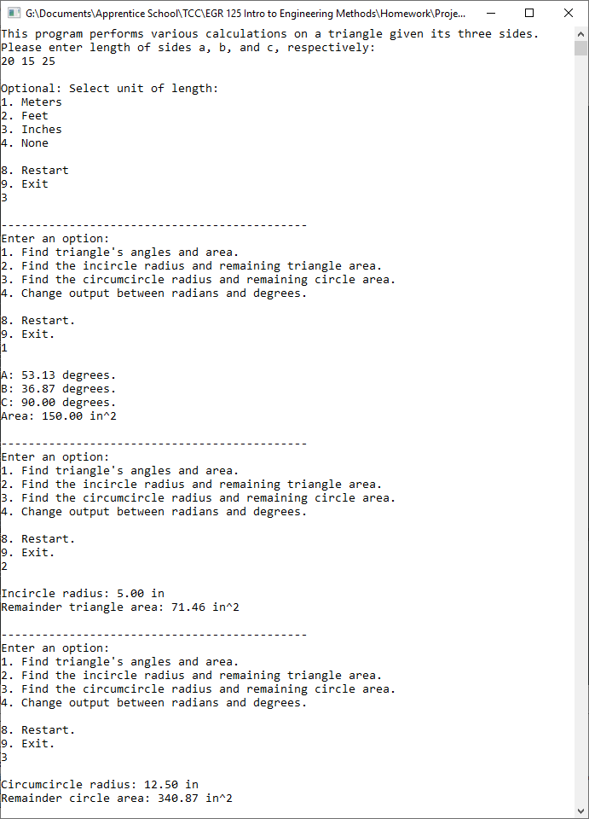

**a = 14, b = 15, c = 16**  
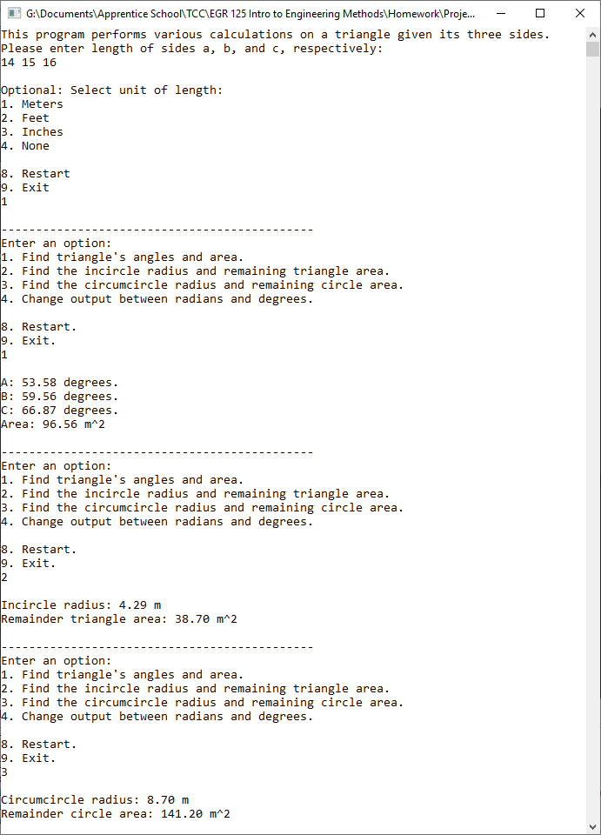

**Invalid triangle error and requesting new input**



**Triangle Display**

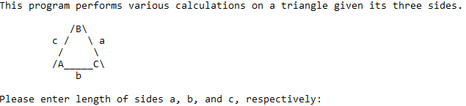

**Optional Display: Radians and Units**

